Quiz-1

**1.1 Do the Camera Calibration (2.5%):**

* Using MATLAB camera calibration toolbox
* Using the given images
* Write the calibration result in your report with an accuracy analysis

**1.2 Project a point onto the image (2.5%):**

* Point (18, -20, 90) in the camera coordinate frame, using the calibration result
* Write the equation or code you used and the location of the image point

❖Time and submission

5+35+5 mins, uploaded report to CANVAS in Assignments -> Quizzes -> Quiz 1

Quiz 1 Report

# Question 1.1

## Step 1: Convert Images

Convert .png to .jpg using png2jpg.

f=dir('*.png');

fil={f.name};

for k=1:numel(fil)

file=fil{k};

new_file = strrep(strcat('I',file),'.png','.jpg');

im = imread(file);

imwrite(im, new_file);

end

## Step 2: Calibrate Gui

Use calib_gui to “Show Images” and then “Extract Grid Corners”.

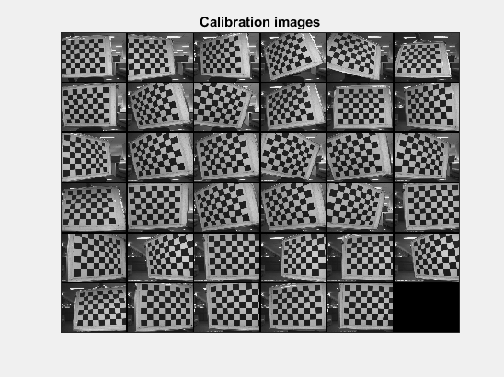

### 2.1 Extract Grid Corners

### 2.2 Calibrate

Calibration results after optimization (with uncertainties):

Focal Length: fc = [ 894.97820 900.34566 ] +/- [ 17.69205 16.97946 ]

Principal point: cc = [ 466.47259 431.06333 ] +/- [ 13.27013 12.23312 ]

Skew: alpha_c = [ 0.00000 ] +/- [ 0.00000 ] => angle of pixel axes = 90.00000 +/- 0.00000 degrees

Distortion: kc = [ -0.15288 0.10051 0.00913 -0.00553 0.00000 ] +/- [ 0.02488 0.04963 0.00299 0.00308 0.00000 ]

Pixel error: err = [ 2.69739 2.39372 ]

Note: The numerical errors are approximately three times the standard deviations (for reference).

### 2.3 Reproject on Images

### 2.4 Recomp. Coners

### 2.5 Calibrate Again

Calibration results after optimization (with uncertainties):

Focal Length: fc = [ 884.63022 884.54092 ] +/- [ 4.18227 3.99370 ]

Principal point: cc = [ 504.86287 424.94239 ] +/- [ 3.28130 2.85500 ]

Skew: alpha_c = [ 0.00000 ] +/- [ 0.00000 ] => angle of pixel axes = 90.00000 +/- 0.00000 degrees

Distortion: kc = [ -0.19600 0.14861 0.00218 -0.00003 0.00000 ] +/- [ 0.00652 0.01488 0.00067 0.00071 0.00000 ]

Pixel error: err = [ 0.57351 0.63924 ]

Note: The numerical errors are approximately three times the standard deviations (for reference).

# Question 1.2

## Step 1: Projection

clc;

clear;

%Get the following parameters from your calibration

px=504.86287;%Principal point X

py=424.94239; %Principal point Y

fx=884.63022; %Focal length

fy=884.54092;

%Homogenous transformation matrix

K = [fx,0,px;

0,fy,py;

0,0,1];

X_cam = [18;-20;90;1]; %3D location

IM = eye(3,4);

x = K*IM*X_cam;

u = x(1)/x(3)

v = x(2)/x(3)

**Equations Used:**

U1 = fx*x/z+px

V1 = fy*y/z+py

**Answers:**

u =

681.7889

v =

228.3777